## Lab 01

## Done by : 21k-3881

## Tasks

1. Find the IP address of the computer you are currently using.

Command: ipconfig

IP address: 192.168.1.4

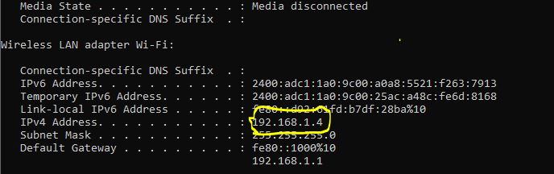

1. Find the IP address of the computer you are currently using, plus MAC address, the gateway, plus

whether DHCP is turned on.

Command: ipconfig /all

IP address: 192.168.1.4

MAC address: 5C-EA-1D-90-2B-C9

Gateway: 192.168.1.1

DHCP: Enabled

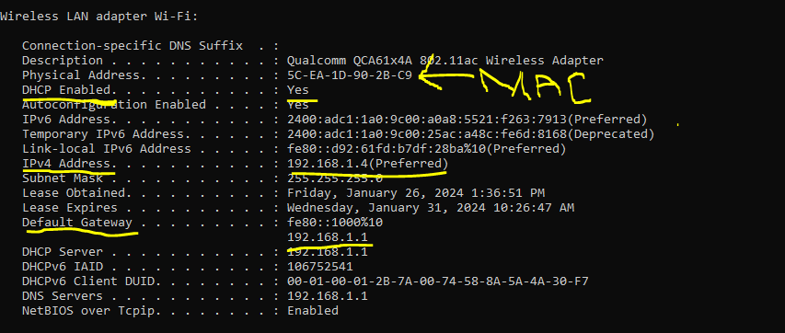

1. Display the host name of the computer.

Command: hostname

Hostname: DESKTOP-88AK2F1



1. Check for basic IP connectivity between two computers by name and IP address. How can basic IP connectivity be checked? What are the reasons why there is no connectivity?

Command: ping

Reason: Because of no response from any other computer. Or incorrect IP address or host name. Or firewall blocking ping request.

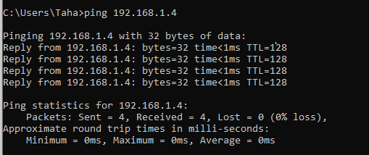

1. Find out which ports on your host are connected to applications. Connect the browser to some external web page before running the appropriate command.

Command: netstat

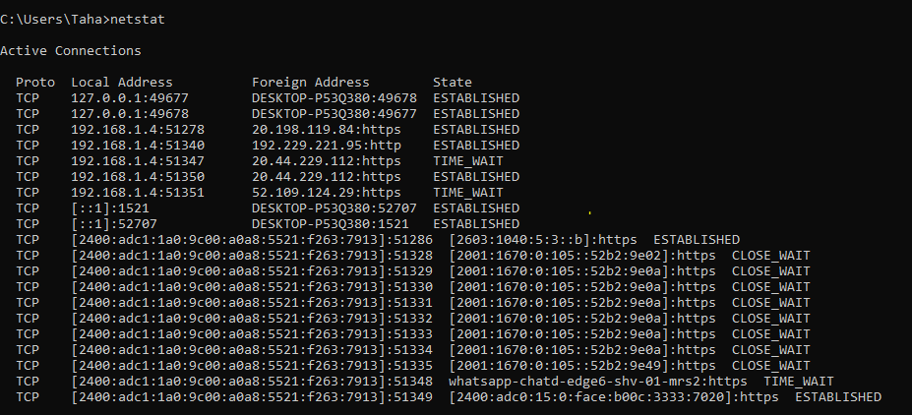

1. Find the path of routers to www.google.com. What is it’s IP address? How many hops involved in the path?

Command: tracert [www.google.com](http://www.google.com)

13 hops used in the path

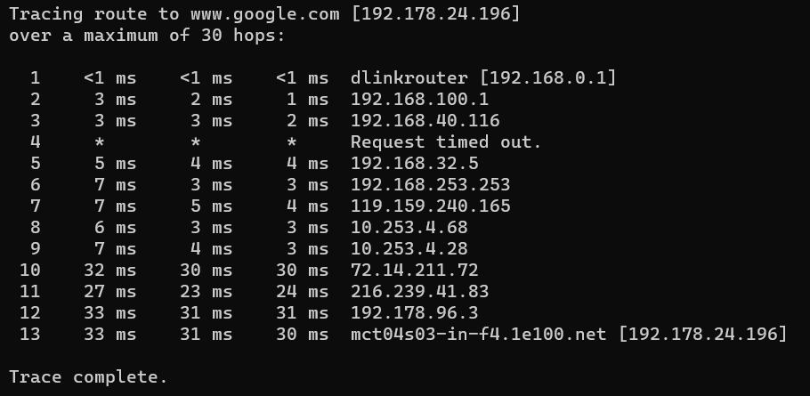

1. A ping to 192.168.0.2 works but a ping to the machine’s name “blue_machine” fails. What could be wrong?

Reason: because ping couldn’t find a host name called “blue machine”.Or destination host unreachable.

8) Which type of cable will you use to connect in a normal home installation?

Answer: Ethernet cables(Cat5e,Cat6,Cat6e) are used.

9) Can you connect a Switch to another Switch or a router to a PC using a straight- through cable?

Explain your answer.

Answer: Yes, we connect switch to another switch or a router to a PC using a straight-through cable when we connect various devices along with various functionalities. Straight-through cables are used for connecting devices with dissimilar communication roles.

10) Write a brief report on your home network or any organizational network including topology, 1 page max).

Answer: My home network is designed with a star topology, where a central wireless router serves as the main connection point. This router links various devices, including computers, smartphones, etc , through a mix of wired and wireless connections. Security is a priority, with WPA3 encryption employed for safeguarding the network. To maintain the network's security, regular software updates are applied to all connected devices. This configuration ensures a well-managed and secure environment for our diverse range of devices, enhancing protection against potential threats.